Choice Price AB test result Update as of 2017-10-06 1:45 AM:

As of this Morning, 49 days into the test, the Test Group outperformed the Control Group in Revenue per Visitor,

1. The conversion rate of the Test Group is -9% lower than that of the Control Group
2. The ATS of the Test Group is +13% Higher than that of the Control Group
3. All in all, the Test Group is giving us a +4% lift in Revenue per Visitor over the control Group
4. The ATS of the Test Group is significantly higher than that of the Control Group, but the Conversion Rate of the Test Group is significantly lower. The combined effect of the Test Price Offer is generating +4% lift in Revenue per Visitor over the Control Price Offer.

You can find the report here, <https://data.points.com/#/views/ChoicePriceTestAug_17/Summary?:iid=1>

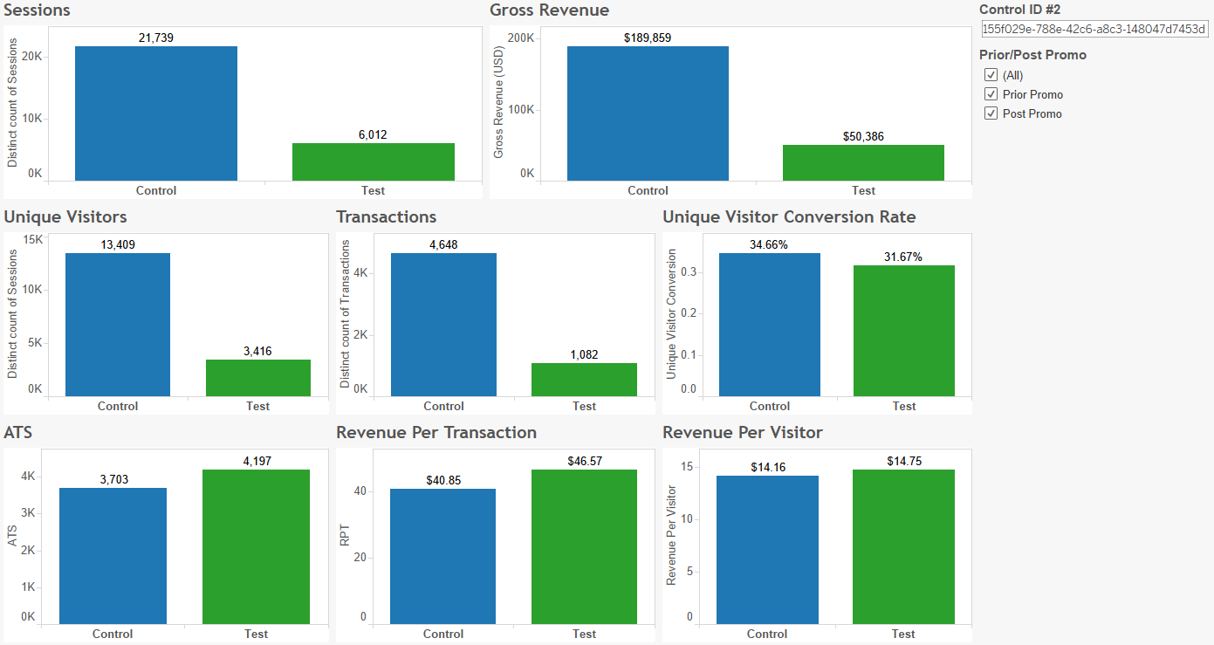

Post Promo

